**Project 1 Test a Perceptual Phenomenon**

**Xin Mu**

**1. Background**

In this project, I investigated a classic phenomenon from experimental psychology called Stroop effect. In [psychology](https://en.wikipedia.org/wiki/Psychology), the Stroop effect is a demonstration of interference in the [reaction time](https://en.wikipedia.org/wiki/Reaction_time) of a task. When the name of a color (e.g., "blue", "green", or "red") is printed in a color not denoted by the name (e.g., the word "red" printed in blue ink instead of red ink), naming the color of the word takes longer and is more prone to errors than when the color of the ink matches the name of the color.1

In this project, I investigated a dataset obtained from a Stroop task. In this Stroop task, 24 participants are presented with a list of words, with each word displayed in a color of ink. The participant’s task is to say out loud the color of the ink in which the word is printed. The task has two conditions: congruent word condition and incongruent word condition. In the congruent word condition, the words being displayed are color words whose names match the colors in which they are printed; in the incongruent word condition, the words displayed are color words whose names do not match the colors in which they are printed. In each case, the time it takes to name the ink colors in equally-sized lists by the participants are measured. Each participant will go through and record a time from each condition. The statistical analysis of this dataset is as followed.

**2. Results and Discussions**

**a.** **What is our independent variable? What is our dependent variable?**

Independent variable: whether the word name and the font color of the words are the same or not (congruent word condition or incongruent word condition).

Dependent variable: the reaction time to say out loud the font color in which the word is printed.

**b. What is an appropriate set of hypotheses for this task? What kind of statistical test do you expect to perform? Justify your choices.**

*The hypotheses I will test in this project:*

Null hypothesis: congruent word condition and incongruent word condition have the same effect on reaction time.

Alternative hypothesis: congruent word condition takes less reaction time than the incongruent word condition.

*Math formula: $$H_{0}: µ_{Congruent }= µ_{Incongruent }$$*

$$H_{A}: µ_{Congruent }< µ_{Incongruent }$$

where $µ_{Congruent }$ is the average reaction time under congruent word condition, and $µ_{Incongruent }$ is the average reaction time under incongruent word condition.

*The statistic test:*

I will perform the dependent one-tailed t-test for two paired samples to do this hypothesis testing.

*Justify my choice:*

In this experiment, the same 24 people were taking the tests under two conditions to get two samples. Since the same subject was tested under two conditions, these two samples are dependent samples. Therefore I use the dependent t-test to do the hypothesis testing.

**c. Report some descriptive statistics regarding this dataset. Include at least one measure of central tendency and at least one measure of variability.**

I have calculated some descriptive statistics, and the results are shown in Table 1 and Table2. Table 1 shows the central tendency measures and Table 2 shows the variability measures.

Table 1. Central tendency measures

|  |  |  |
| --- | --- | --- |
|  | Congruent Sample | Incongruent Sample |
| Sample Mean | 14.05 | 22.02 |
| Median | 14.36 | 21.02 |

Table 2. Variability measures

|  |  |  |
| --- | --- | --- |
|  | Congruent Sample | Incongruent Sample |
| Range | 13.70 | 19.57 |
| Variance | 12.67 | 23.01 |
| Standard Deviation | 3.56 | 4.80 |

*Discussion:*

The sample mean and median of the reaction time under incongruent word condition are both larger than those under congruent word condition. In the meantime, the range, variance and standard deviation of the reaction time under incongruent word condition are also uniformly larger than those under congruent word condition. This means the incongruent word condition tends to take longer reaction time, and also tend to have larger variability.

**d. Provide one or two visualizations that show the distribution of the sample data. Write one or two sentences noting what you observe about the plot or plots.**

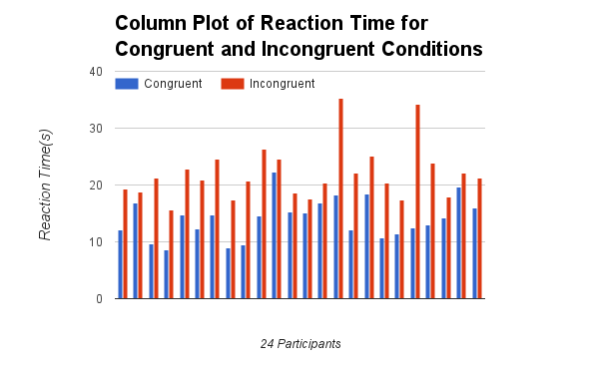

Figure 1. Column Plot of Reaction Time for Congruent and Incongruent Word Conditions.

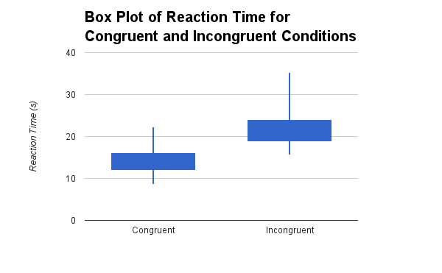

Figure 2. Box Plot of Reaction Time for Congruent and Incongruent Word Conditions.

I plotted the column plot of the reaction time under two conditions, which is shown in Figure 1. We can see the reaction time under incongruent condition for each participant is uniformly larger than that under congruent condition. For each condition, the distribution of the reaction time has no clear trend, and they look like random distribution.

The box plot shown in Figure 2 shows that the reaction time under incongruent condition has larger median and range than that under congruent condition.

So far, from the calculated descriptive statistics and dataset visualizations, we have observed that the reaction time under incongruent condition is likely to be larger than that under congruent condition. In the following, I will perform the one-tailed t-test to test this hypothesis.

**e. Now, perform the statistical test and report your results. What is your confidence level and your critical statistic value? Do you reject the null hypothesis or fail to reject it? Come to a conclusion in terms of the experiment task. Did the results match up with your expectations?**

*Hypothesis Test Formula:*

$$H_{0}: µ_{Congruent }= µ_{Incongruent }$$

$$H_{A}: µ_{Congruent }< µ_{Incongruent }$$

This is a one-tailed dependent t-test.

The degree of freedom: n -1 = 23.

The different α levels and their corresponding critical t values for the 23 df are shown in Table 3.

Table 3. α levels and their corresponding critical t values.

|  |  |  |  |  |  |
| --- | --- | --- | --- | --- | --- |
| α level | 5% | 2.5% | 1% | 0.5% | 0.05% |
| t* | -1.714 | -2.069 | -2.500 | -2.807 | -3.768 |

The t-statistic:

, where *s* is the sample standard deviation of .

Plugging in these values:= 14.05, = 22.02, *s* = 4.86, *n* = 24, and obtain the t statistic as - 8.04. This t statistic value is less than the t* of 0.05% confidence level, therefore it falls into the 0.05% critical region. Therefore I reject the null hypothesis, which means congruent word condition gives significantly less reaction time than the incongruent word condition.

Formally write out this t-test result: t (23) = -8.04, p < .00001

The confidence interval is given by: 

So the 95% CI is: (-9.67, -6.27).

The next, I calculate the effect size measures:

Cohen’s . This Cohen’s d is very large (much larger than 0.8, which is regarded as a measure of large effect size), which means the effect size is very large and this t-test result is reliable.

. This means 74% of the whole reaction time difference comes from the different word conditions (congruent and incongruent conditions).

*To summary*, my hypothesis test shows that, under the congruent word condition, the reaction time is significantly less than that under the incongruent word condition. This t-test result matches my expectation. Under the congruent condition, the words and the font colors of the words match with each other, and therefore it is easier for the participants to say loud out the correct font color; on the contrary, the incongruent condition causes difficulties for the participants to say out the font color correctly because the mismatch between word name and their font colors can interfere with people’s reaction time. In a word, my hypothesis test results make sense.

**f. Optional: What do you think is responsible for the effects observed? Can you think of an alternative or similar task that would result in a similar effect? Some research about the problem will be helpful for thinking about these two questions!**

I think the longer reaction time for the incongruent condition is because the mismatch between word name and their font color is a kind of interference for the participants to say out the font color. Therefore the average reaction time under incongruent condition is longer.

A similar task coming up in my mind is: under congruent and incongruent word conditions, let the participants to say out the word name, not their font colors, and then record the reaction time of each group. This test will give a similar result, because the mismatch between the word name and the font color would also be a kind of interference for the participants to say out the word name correctly.

**3. Conclusions**

In project, I tested a perceptual phenomenon – Stroop effect – using one-tailed dependent sample t-test. From this study, I find, under incongruent word condition, the reaction time for naming the color of the word takes longer time than under congruent word condition, which meets my expectation. The t-statistic, 95% confidence interval and effect size measures are calculated in this study, and a solid analysis is provided.

**4. Reference**

1. https://en.wikipedia.org/wiki/Stroop_effect.